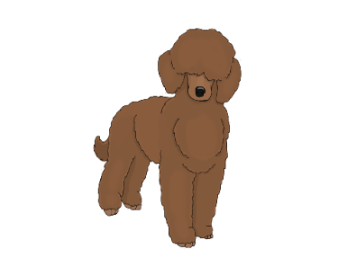 It’s the last great
Poodle Palooza!
Come join our party for Poodles and all People that love them!
A benefit for Poodle health research through the Poodle Club of America Foundation,
and the Columbia Poodle Club, Inc.**
Date: Sunday, September 29, 2024
For all who just love Poodles or are owned by one, meet other Poodle lovers and join the fun!
All well socialized Poodles welcome - Standards, Minis and Toys
*Full lunch provided – gourmet catered grub*
Poodle Olympics – fun games and prizes! Everyone young and old(er) can compete with their Poodle – tons of fun.
Professional photographs for you and your dog
*Silent Auction/artist’s Quilt live auction!*
Lot of wonderful space for your Poodle to play at liberty with other Poodles.
Where: 30200 NW 18th Pl., Ridgefield, WA 98642 (cross road: 299th St.)
When: Sunday, September 29, 10:30 AM – 3:00 PM
Cost: $30 per person (pay at the door); children 12 and under free.
RSVP required to Paula Morgan, 360-760-4262, paula@bpmorgan.com, with names of all guests.
We have a safe and secure fenced and cross fenced property for your pets with shade and separate areas for different sizes. Puppies should be at least two weeks from their last puppy shot.
** 501(c)(3) non-profit organizations dedicated to Poodle welfare.
Questions? Ask Paula:
541-973-0622; paula@bpmorgan.com

